

EDITION 10


THE NEW

SPICE ROUTE

Two significant events in the last few months have brought pride to all Indians: the successful Chandrayaan Mission and the New Delhi G20 Summit.

During the G20 summit in Delhi, an exciting development took place on the sidelines—the establishment of the India-Middle East-Europe Economic Corridor (IMEC), christened as the 'Spice Route.' The primary objective of this new spice route is to create the India-Middle East-Europe Economic Corridor (IMEE EC), oﬀer-ing faster and more cost-eﬀective sea and rail transit options to West Asia and Europe, with Mumbai potentially serving as the main hub.

Historically, Kozhikode Angadi was the central hub of the original spice route. Unfortunately, the Malabar region plays a minor role in this new venture. However, the New Spice Route presents a re-markable opportunity to re-establish Kerala's prominence. To achieve this, a strategic, long-term vision and a concerted action plan are essential.

While the old spice route primarily facilitated the exchange of spices, it also fostered the exchange of valuable goods, knowl-edge, and ideas. It played a pivotal role in cultural exchanges be-tween the East and West, contributing to the spread of ideas, reli-gions, and artistic influences. The New Spice Route transports a wide range of commodities, fostering cultural exchange and driv-ing rapid technological advancements, international trade, job creation, and economic development in participating regions.

In this modern-day situation, how do we ensure that the Malabar region capitalizes on the opportunities to the maximum extent?

Technological advancements are now the driving force behind economic development, with ecosystems acting as catalysts. Le-veraging geographical advantages with technological advance-ments forms the key success factor. The successful space mission, especially the Chandrayaan mission, teaches us many lessons. The Indian Space Research Organization (ISRO) benefits from the in-tellectual capital in the southern districts of Kerala and Tamil Nadu. The magnetic equator passing through Thumba, Trivan-drum, provided an ideal location for rocket experiments, leading to the establishment of the Vikram Sarabhai Space Centre (VSSC). Many ISRO scientists, including Dr. APJ Abdul Kalam, have shaped their careers at VSSC.


How do we replicate this success story in the 'New Spice Route opportunity'? Spices have historically been valued for their im-mune-boosting and therapeutic properties. Ongoing research aims to develop drugs for diseases like cancer. The 2023 Nobel Prize in Chemistry was awarded for the discovery and synthesis of quantum dots, which can guide surgeons during tumor removal. Nano curcumin, extracted from turmeric grown abundantly in Kerala, is an eﬀective anti-inflammatory agent, with the poten-tial to develop locally grown spice-based anti-inflammatory drugs.

Research into cancer treatment and prevention is also ongoing. Garlic, rich in cysteine, supports glutathione production, which can protect both cancer cells from treatment toxicity and healthy cells from chemotherapy and radiation damage. Pepper com-pounds like piperine and capsaicin have shown promise in inhibit-ing cancer cell growth and inducing apoptosis in certain cancer types.

Leveraging Kerala's ecosystem and technological advancements, world-class research and manufacturing centers can be estab-lished. This would position India at the forefront of pharmaceuti-cal research and help the Malabar coast regain its dominance on the New Spice Route.

Excitingly, India's first Graphene Innovation Centre is set to be es-tablished in Kerala, a joint venture of Digital University of Kerala, Centre for Materials for Electronics Technology (C-MET), and Tata Steel Limited. Graphene-based technologies hold great potential for revolutionizing energy production and medicine, oﬀering a significant boost to the region's economy through public-private initiatives.

In conclusion, the New Spice Route presents Kerala with a re-markable opportunity to re-establish its prominence and contrib-ute to the rapid development of the region. Leveraging its histori-cal significance, technological capabilities, and research poten-tial, Kerala can play a pivotal role in the economic growth of India and the world.

HARIKUMAR M

Chief Business Oﬃcer,

AIMER Business School


TOP NEWS

ROUNDUP

India is global leader in AI skill penetration: Stanford University’s AI Index Report 2023

Stanford University’s AI Index Report 2023 has revealed India's role in the global Artificial Intelligence (AI) revolution. The report shows that India is a leader when it comes to AI skills as it has the highest AI skill penetration rates in the world. Additionally, in 2022, Indian software
1 developers contributed to a big chunk (around

24.2 per cent) of AI projects on GitHub.

(Business News India)

2

3

Hiring in the Indian IT sector shrinks for the first time in 25 years

Amid spending cuts by Western countries and geopolitical risks, the hiring by nine out of 10 Indian IT companies fell in the July-September quarter, Mint reported on Monday. It is the first time the hiring in this sector, considered to be key in the country's economic growth, has shrunk in over 25 years.

(Business Standard)

These 4 trends could lead to a 7%
GDP growth in the next decade:

Let's find out

Mutual fund Investment Firm Franklin Templeton (FT), in a recent note, highlighted that investors are increasingly recognizing the Indian growth story.

While investors are aware of India’s ambitious targets for growth, exports and consumption, they may be less aware of the commitment to innovation and liberalization required to achieve these targets, it stated.

These, as per the report, include:

- India technology stack: the Unified Payments Interface (UPI) is creating a cascade of innovation.

- Infrastructure: new fast trains with dedicated freight corridors between major cities, and a focus on renewable energy.

- Production Linked Incentives (PLI) and a focus

on manufacturing for export.

- Pursuing free trade agreements and the In dia-Middle East-Europe trade corridor.



 AIMER
ROUND-UPS

Expert Talk By

Ashraf Kakat

Participating in the EXPERT Talk session organized at the AIMER campus, the Managing Director of The Royad Group of Companies Mr. Asherf Kakat shared his business success story with AIMER students. The diﬃculties faced in business and ways to overcome them were also shared with the stu-dents. The dos and don'ts of running a business successfully were discussed in detail.

Stock Market

Workshop

A stock market Workshop was conducted by Stock Market Expert, Mr Kishore from Team Avenue Trivandrum. The students had a unique opportunity to learn, engage, and even make live share purchases right in the classroom. It was an educational experi-ence that brought the world of finance to life for our future inves-tors.

The event was a great success, and it's a testament to our com-mitment to providing practical, experiential learning opportuni-ties for our students.

Faculty Development Program

AIMER faculties successfully completed the Faculty Development Program on the topic "Training Program On Innovative Teaching and Learning Pedagogy” from the Research Foundation of India

EL-GOLAZO

AIMER B School Students Organized a Football Tournament (EL-GOLAZO).

MKC Academic Director Dr. Amir Hassan kicked oﬀ the tourna-ment.

Six teams of students and staﬀ battled it out with DYNAMOS FC emerging as the winner and team Black and White finishing as runners-up.
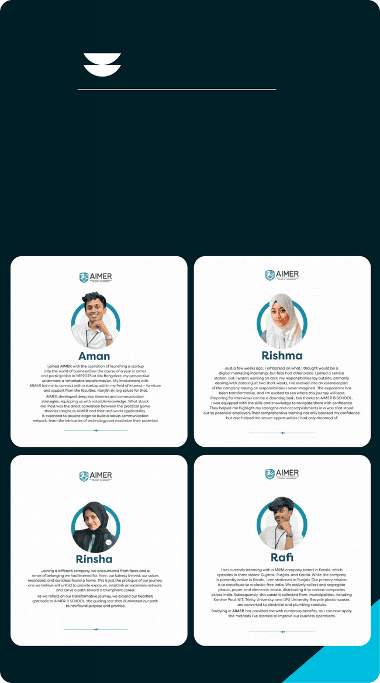

AIMER
ROUND-UPS

Internship

Success Stories

AIMER organized an open-day celebration for staﬀ and students. The programs were organized under the leadership of Chief Oﬃcers H.K. and Dr. S.S., Dean M.K., and Students Representative Council (SRC) members Safwan Ahmed, Ms. Jinsha, Muhammad Numan, and Marshad. The day-long program concluded with sports, arts, and cultural competitions.


COMPANY
WATCH

Royad Farmhouse

Nestled in the heart of Kerala, Royad Farmhouse, built by entre-preneur Ashraf Kakat, oﬀers a serene escape for those seeking a respite from the urban hustle. This idyllic retreat, ensconced amidst verdant paddy fields and fragrant spices, fosters a pro-found connection between visitors and nature.

Kakkat's realization that "nature is an encyclopedia" led to the creation of Royad Farmhouse, providing a space for guests to dis-engage from the frenetic urban life and embrace the tranquility of the natural world.

The farmhouse seamlessly blends cozy Italian design with Kera-la's natural beauty, oﬀering guests a harmonious backdrop for re-laxation. Amidst the gentle fragrance of fresh paddy and the rich aroma of spices, visitors experience life's essence.

Royad Farmhouse is a limited edition luxury retreat that marries modern aesthetics with traditional elements, catering to nature enthusiasts and travelers seeking sanctuary. Beyond mere ac-commodation, it oﬀers immersive activities like farm tours and hands-on farming experiences, creating unique and memorable visits.

For business professionals, Royad Farmhouse serves as a tranquil escape, allowing them to recharge and find balance amidst the natural surroundings.

Moreover, Royad Farmhouse is not just a sanctuary for humans but also for diverse bird species, oﬀering a chance for guests to appreciate the marvels of avian life.

In summary, Royad Farmhouse, founded by Ashraf Kakat, fosters a deep connection between humans and nature, providing a serene escape in the Kerala countryside. Its Italian-inspired villa, commitment to sustainability, and appeal to business retreats make it a haven that cultivates lasting memories and a profound appreciation for the natural world.



QUIZ TIME

One winner will get free gifts & a mention in the next edition

Identify this logo

Padma Bhushan award winner Nandan Nilekani was the co-founder of which company?

- Tata Steel

- Infosys

- Wipro

- Hindustan Unilever

REPLY YOUR ANSWER(S)

IN THE WHATSAPP CHAT

* Correct answer will be in the next edition.

Last edition's answer is ‘ b. Apple, c. Zerodha, e. Uber ’

Last Edition's

Quiz Winner!

Huda Fathima
Studentt


Get in Touch with AIMER's business-growth experts to learn diﬀerent ways to scale your business.



